Creating New Game Pieces for the BioRubeBot Project

*All current and future sprites should be placed within biorubebot-dev-master* ▸ *Assets* ▸ *Sprites*

*All current and future prefabs exist at biorubebot-dev-master* ▸ *Assets* ▸ *Prefabs*

# Creating Images

Pre-requisites: Adobe Photoshop/Illustrator or something similar

## Within photoshop:

1. Create a new document
2. Layers will be used to produce a final “sprite” foreground
3. Use a “stroke” filter to create the background
4. Create a duplicate of the image that now has a “background” stroke around it
5. On the “background” layer, fill the entire object with black
6. On the “foreground” layer, remove the stroke filter that was added

You should now have a brand new artwork to build your sprite, then prefab, which will be discussed in the next section.

Note: Photoshop and Illustrator are not very easy tools to use if the individual has never used them. It is highly recommended to go through some tutorials on YouTube.com©

# Creating The Sprite and Prefab within Unity

This section to be referenced after new artwork has been created.

1. In the left-hand pane with the heading hierarchy, select the small “Create” dropdown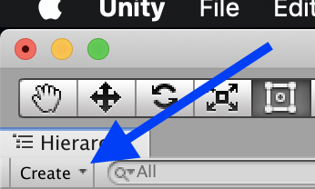
2. Select “2D Object ▸ Sprite”
3. Label the new 2D Object to reflect the new game piece being made
4. Drag that “New Sprite” down into the Project pane and drop it into the “Assets ▸ Sprites” folder
   * This will need to be done for each layer of the sprite
   * You may need to create multiple sprites and repeat the process if the game piece requires multiple parts
5. Pull all necessary pieces for the final game piece object into the top left pane
6. Grab all pieces from under the parent sprite created in the left-hand pane and drag this into the “Assets ▸ Prefabs”
7. The difficult part really starts to happen for determining the behavior and how to go about accomplishing this.

Note: It is highly recommended to review previous prefabs and learn how they instantiated the desired behavior onto the game pieces. It’s not recommended to necessarily copy and paste however it is recommended to not “reinvent the wheel” where applicable.